N43RF Ocean Winds Mission 7 February 2011

During this mission we observed several occurrences of significant differences between AOC SFMR/ProSensing wind values and AVAPS II GPS dropsondes values at splash. Below is a summary of the events leading up to the modification of the flight profile to determine which of the two remote sensing instruments was not functioning optimally.

On 7 February N43RF departed Halifax, Nova Scotia to fly the eighth mission for the 2011 Winter Ocean Winds project. After a two hour ferry we began a descent into the operations area over the North Atlantic Ocean well east of Newfoundland at 1535Z.

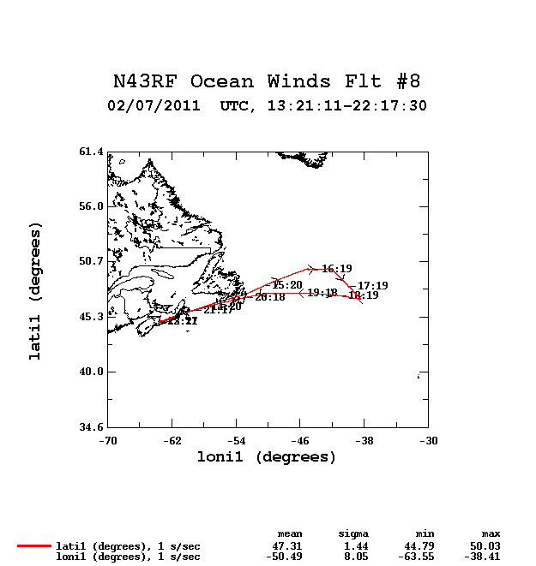

During this mission we observed several occurrences of significant differences between AOC SFMR and ProSensing surface wind speed estimates and AVAPS II GPS dropsonde wind speeds at splash. We define significant differences as 3 m/s or greater between observed AOC SFMR and ProSensing surface wind values and GPS dropsonde wind values at splash. After a discussion among the aircraft commander, flight directors and the Principal Investigator it was agreed to follow the recommendation of the aircraft commander and deploy a GPS dropsonde toward the end of our mission time in the operations area, then do a spiral descent to approximately 3000 feet and overfly the GPS dropsonde splash location. This would provide the scientific crew a preliminary, albeit a single point, comparison of the AOC SFMR and ProSensing surface wind outputs to the GPS dropsonde wind speed at splash from a lower altitude.

A GPS dropsonde was deployed at 18:31:15Z from flight level 7493 feet radar altitude at location 47.495N 41.923W. The GPS dropsonde splashed 3 minutes and 29 seconds later (18:34:44Z) at 47.464N 41.841W, 3.81 nm ESE from its launch location.

After the GPS dropsonde was deployed, N43RF commenced a left turn spiral descent at 18:31:21Z to approximately 3000 feet (awl) in an attempt to overfly the GPS dropsonde splash location. The flight crew did an outstanding job in positioning the aircraft to within one nautical mile (0.85 nm based on aircraft location 47.452N 41.852W) of the GPS dropsonde splash location (47.464N 41.841W) at time 18:35:06Z which was 22 seconds after the GPS dropsonde splashed.

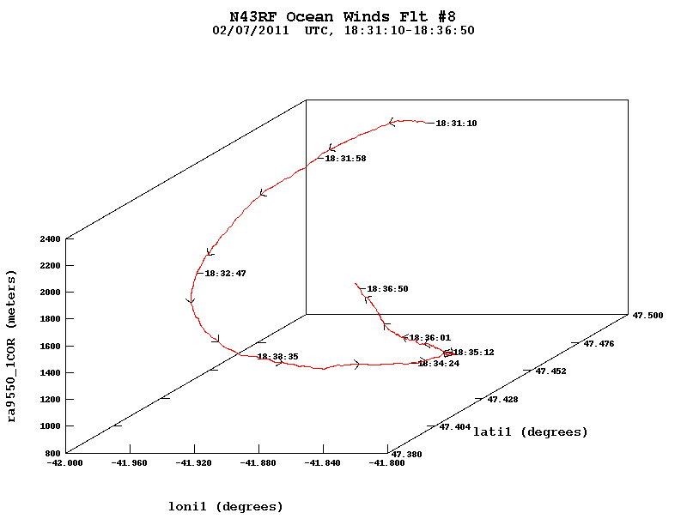

It is interesting to note that during the descent to 3000 feet radar altitude there was a dusting of sea salt residue on the cockpit windscreens at 18:32:41Z (nose video). However a short time later the residue was washed away by liquid precipitation.

At 3060 feet radar altitude the aircraft was near cloud base (down-looking video) which provided a mostly cloud free view of the ocean surface for the ProSensing instrumentation. The AOC SFMR and ProSensing wind speed values and aircraft extrapolated sea level pressures provided below are a 10-second average over time period 18:35:05Z – 18:35:15Z when the aircraft was in fairly straight and level flight.

Dropsonde wind speed at splash: 30.5 m/s

AOC SFMR | ProSensing wind speed: 29.0 m/s | 29.6 m/s

Dropsonde sea level pressure (slp) at splash: 989.3mb

Aircraft extrapolated slp from RINU GPS alt (905.5m): 989.3mb

Aircraft extrapolated slp from Novatel GPS alt (913.0m): 990.2mb

Aircraft extrapolated slp from HG9550 radar alt (937.2m): 993.2mb

Aircraft extrapolated slp from HG9550-cor radar alt (931.4m): 992.5mb

The aircraft flight-level data was examined when the plane was at 3068 feet radar altitude (static pressure 883.3mb) and compared to the GPS dropsonde output for that same altitude. For the comparison I used the aircraft’s corrected static pressure as the altitude reference since we have great confidence in that value based on several activities (trailing cone, balloon flyby, aircraft inter-comparison, etc.) that have been performed over the last 20 years.

The aircraft flight-level data provided in the table below are a 10-second average over time period 18:35:21Z – 18:35:31Z when the aircraft was in fairly straight and level flight. The aircraft position is centered on 18:35:26Z, which is 1.12nm horizontally from and 2:08 after the GPS dropsonde passed through the 883.3mb pressure surface. The GPS dropsonde data is presented both in raw (black) and quality-controlled (red).

|  |  |  |  |  |  |  |  |  |  |  |  |  |  |  |
| --- | --- | --- | --- | --- | --- | --- | --- | --- | --- | --- | --- | --- | --- | --- |
| **N43RF AIRCRAFT FLIGHT LEVEL DATA**  **COMPARED TO DROPSONDE DATA AT ALTITUDE** | | | | | | | | | | | | | |  |
| 110207I Winter Ocean Winds Mission | | | | | | | | | | | | | |  |
|  | | | Time(Z) | Static Pressure (mb) | | Air Temperature (C) | Relative Humidity (%) | Wind Dir | Wind Speed (m/s) | | | Lat | Lon | Distance (nm) |
| Dropsonde | | | 183318 | 883.2 | | -2.80 | 95 | 300.0 | 35.10 | | | 47.476 | 41.877 | 1.12 |
|  |  |  |  | 883.4 | | -2.60 | 95 | 300.0 | 35.60 | | |  |  |
|  |  |  |  |  | |  |  |  |  | | |  |  |
| N43RF | | | 183526 | 883.3 | | -2.67 | 94 | 298.7 | 35.50 | | | 47.458 | 41.870 |
|  | | |  |  | |  |  |  |  | | |  |  |  |
|  |  |  |  |  |  |  |  |  |  | | |  |  |  |
| Dropsonde data highlighted in red indicates quality controlled values. | | | | | | | | | | | |  |  |  |
|  |  |  |  |  |  |  |  | | |  |  |  |  |  |
| N43RF flight-level data is a 10-second average from 18:35:21Z - 18:35:31Z except for position (lat,lon). | | | | | | | | | |  |  |  |  |  |
|  | | | | | | | | | |  |  |  |  |  |

Upon completion of our work at approximately 3000 feet radar altitude, the aircraft began a climb to 10000 feet at 18:36:10Z. During the climb out the aircraft encountered precipitation (nose video) and then a dusting of sea salt residue appeared on the cockpit windscreens as the aircraft was in and out of cloud tops at 18:37:22Z at altitude 4623 feet (RINU GPS) or 4637 feet (Novatel GPS) or 4754 feet (HG9550 radar altitude) or 4715 feet (HG9550 corrected radar altitude). Since we were leaving the operations area, the Winter Ocean Winds ORM mandate to exit the operations area when sea salt residue is observed on the cockpit windscreens was implicitly applied.

My conclusions are as follows:

* The descent to approximately 3000 feet radar altitude provided the AOC SFMR/ ProSensing instrument a mostly cloud-free view of the sea surface. The AOC SFMR and ProSensing wind outputs of approximately 30 m/s at the lower altitude were consistent with AOC SFMR and ProSensing wind outputs from the higher altitude in the operations area. This implies that several AVAPS II GPS dropsondes wind values measured at splash were erroneously lower than the AOC SFMR and ProSensing wind speed values.
* The descent to approximately 3000 feet radar altitude provided the opportunity to compare flight-level data to AVAPS II GPS dropsonde output at altitude, as well as aircraft extrapolated sea level pressure to dropsonde splash pressure. The results show excellent agreement of the aircraft’s corrected static pressure and derived ambient temperature to dropsonde static pressure output and air temperature measurement at altitude. This can be attributed to the extensive and meticulous preparation of the aircraft’s scientific instrumentation and onboard data system by SEB. However regarding the comparison of aircraft extrapolated sea level pressure to dropsonde splash pressure there were several discrepancies noted among the various outputs. This was a function of which altimeter source was selected for the aircraft’s aircraft derived extrapolated sea level pressure value.
* An additional result of this maneuver indicates that we may need to reexamine our emphasis on altitude as it relates to the occurrence of sea salt aerosols. The maneuver highlighted the fact that sea salt residue on the cockpit windscreens can occur at various altitudes, and maybe we need to focus more on the anticipated weather conditions at altitude that incur sea salt aerosols and prematurely terminate a mission.

Lastly after my initial request to descend to 3000 feet radar altitude, I was asked “is it going to fix something”. Unfortunately science, particularly meteorology, does not provide immediate straight-forward answers to these types of questions. In this case of trying to determine which of two remote sensing devices, AOC SFMR/ProSensing instrument and GPS dropsondes, were accurately measuring the wind speed at the ocean surface, we needed to safely execute a maneuver that would provide us with data to answer the aforementioned question. By placing the aircraft below cloud base after deploying a GPS dropsonde, and flying the aircraft very near to the GPS dropsonde’s splash location both in time and space, we were able to provide a better comparison for the two remote sensing instruments. Over the years we have done similar aircraft maneuvers, e.g., a series of descents and ascents, for project scientists to verify the relative accuracy of measurements from remote sensing devices as compared to P3 flight-level data. Had the aircraft descended to 500 feet to overfly the GPS dropsonde position I am sure that the P3’s flight-level data would have determine whether or not the GPS dropsonde data was valid as it did at 883mb in the table above.

AOC wind cal flights, trailing cone flights, balloon flybys, aircraft intercomparisons, etc. have made the P3 flight-level data the standard for comparison purposes. And that is borne out not only from research that AOC flight directors have performed over the years but from many research scientists who have scrutinized P3 flight-level data.